**Online Result Processing System**

**With mobile app**

By

Roll No: 31(Group Leader)

Registration No: 202821

Batch No: CSE-26th

Roll No: 01

Registration No: 202791

Batch No: CSE-26th

Roll No: 34

Registration No: 202825

Batch No: CSE-26th

Roll No: 29

Registration No: 202699

Batch No: E-24th

A Project Submitted in Partial Fulfillment of the Requirements for the Degree of Bachelor of Science in Computer Science and Engineering



DEPARTMENT OF COMPUTER SCIENCE AND ENGINEERING

DHAKAINTERNATIONALUNIVERSITY, DHAKA

**APPROVAL**

This Project report entitled **“Online Result Processing With Mobile Apps”** submitted by Md. Mehedi Hassan , Ishrat jahan, Md. Shahidul Islam, Md. Ashiqur Rahman, 26th(Day) , Department of Computer Science and Engineering, Dhaka International University,. It was been accepted as satisfactory for the partial fulfillment of the requirements for the degree of Bachelor of Science and Engineering and approved as to its style and contents.

Board of Examiners :

1……………………………………………………………..…….……………(Supervisor)

2…………………………………………………………………………….……(Examiner)

3…………………………………………………………………….……………(Examiner)

**Declaration**

We, hereby declare that the work presented in this project is the outcome of the Investigation performed by us under the supervision of Md. Shamiul Amin, Lecture , Department of Computer Science and Engineering, Dhaka International University, Dhaka , Bangladesh.

Countersigned Signature

………………………. …………...........................

(Md. Shamiul Amin) Md. Mehedi Hassan

**Supervisor**  ……………………………

Asst. Professor Ishrat Jahan

Department of CSE . ………………………….

Dhaka International University Md. Shahidul Islam

…………………………….

Md. Ashiqur Rahman

**Student**

**Abstraction**

We live in the age of science and technology. Technology makes our life easier and faster. Smart phone is the latest component of technology. It brings the flavor of technology into our hand. Therefore the popularity of mobile application is increasing day by day. In our project, we have considered this situation and developed an android phone based project “Student Result Processing System”. Result processing software is popular desktop or online based software. Most of the Universities in our country publish the result through their website and students have to access university website to get their result. For that reason, we have decided to implement a software which will make the result processing system easier. The Student Result Processing System Project with mobile apps is multi-user software. It has two tiers, one is web based and another one is android apps. In our Web site, student can easily search their result; on the other hand teachers can insert and modify the result. Student also gets their result through their mobile app which makes the result processing system easier to the student.

**Acknowledgements**

First of all, we would like to express our gratitude to the almighty Allah, the most gracious and the most merciful, for giving us energy and ability to complete this project. Then we would like to thanks to our supervisor M. Shamiul Amin, Lecturer, Department of Computer Science and Engineering, Dhaka International University (DIU), for his helpful suggestions in selecting our project topic, planning and implementation of the project work. Also he greatly helped us to improve our project writing and Presentation skills, which, we believe, will benefit us throughout our future career.

We would like to give our special thanks to our parents and friends for their endless love, help and belief.

We warmly thank to A.T.M Mahbubur Rahman, Chairman, Department of CSE of DIU, for his valuable advice and moral support. His extensive discussion around work and interesting explorations in operations has been very helpful for this study.

Finally, we express our thanks to the Department of Computer Science and Engineering for giving us the opportunity to study here and supporting us greatly through our graduate study.

**Contents**

**Approval**

**Declaration of Authorship**

**Abstract**

**Acknowledgements**

**Chapter 1**

**Introduction**

1.1Purpose ……………….………………………..……..9

1.2 Objectives of the work……………………………….10

1.3 Scope…….. ………………………………………….10

1.4 Organization of the Report.…………………….…….10

**Chapter 2**

**Background Study**

2. Introduction..……………………………………………12

2.1 J2EE Description………………………………………13

2.2 JSP Introduction….……………………………………14

2.3 How to Java Server Page works………………………15

2.4 JSP Runtime Environment.……………………………12

2.5 User Interface Design …………………………………12

2.6 PostgreSQL……………………………………………12

2.7 Android……………………………………………12

2.8 XML……………………………………………12

**Chapter 3**

**Requirement Anlysis**

3.1 Funtional Requirement………………………………21

3.11 Admin………………………………………………21

**Chapter 4**

**Software Design**

4.1 Software Processes Model……………………………23

4.1.1 Waterfall Model…………………………………….24

4.1.1 Prototype Model…………………………………….25

4.1.3 Spiral Model………………………………………...25

4.1.4 Choosing the Appropriate Model…………………...26

4.2 Data Flow Diagram of our Software………………….27

4.3 Manual ………………………………………………..28

4.3.1 Home Page……………………….………………….29

4.3.2 Admin Login Page…………………………………..30

4.3.3 Result update page…………………………………..31

4.4.1 Student Search page…………………………………32

**Chapter 5**

**Overall Discussion**

5.1 Conclusion…………………………………….……….36

5.2 Limitation……………………………………………...36

5.3 Future work………………………………....…………36

Bibliography ………………………………………..……..40

Code……………………………………………………….41

**Chapter 1**

Nowadays technology is changing day by day. Society as we know it depends on this fact. That which we take for granted today would have been the staff of science ﬁction as little as ﬁftth years go. In the early years of twenty ﬁrst century, it is computer and intemet that have captured the public imagination and found their way into not just the working environments but increasingly into domestic spaces.

In this modern world, if we are not capable to cope up with those changes than we are not going to stand anywhere in this technical world. Today there is no place for error. Therefore, to make system more effective and efﬁcient we need such technologies where error prone changes must be least.

In this scenario, we are required to develop a web-based application and mobile based apps for Result Processing System. In this time everyone interested to get any information staying in their own home or using their mobile apps Like android or IOs.

The vision of our project decrease the student time and complexity of result processing in our study life.

* 1. **Objective of the Work**

The objective of this application is to develop a system where student and teacher can access the result and get the result with in sort time. A Result Processing System where student can get their result and teacher can modify and update or insert appropriate result from Admin panel

* 1. **Scope**

The scope for the system is as followed:

* Maintain student results record.
* Maintain update result.
* Get the Result through the mobile apps.
  1. **Organization of the Report**

This project has been organized as follows:

* Chapter one shows the introduction of the infrastructure, motivation and goal of this project, how many and what kind of hardware will be needed.
* Chapter two shows our background study of our project.
* Chapter three shows the requirement analysis.
* Chapter four discusses about the software design.
* Chapter ﬁve discusses the conclusion and future work.

**Chapter 2**

**Background Study**

**Introduction**

Burners-Lee was the ﬁrst to combine Internet communication (which has been carrying email and the Usenet for decades) with hypertext (which had been around for decades, but limited to browsing information stored on a single computer such as interactive CD-ROM design). Websites are written in a markup language called HTML, and early versions of html were very basic, only giving websites basic structure (headlines and paragraphs), and the ability to link. This was new and different to existing forms of communication-users could easily negative to other pages by design progressed hyperlinks from page to page.

As the Web and web design progressed, the markup language changed to become more complex and ﬂexible, giving the ability to add objectives like images and tables to a page. Features like tables, which were originally intended to be used to display tabular information, were soon subverted for use as invisible layout devices. With the advent of Cascading Style Sheet (CSS), table-based layout is increasingly regarded as outdated. Database integration technologies such as server—side scripting and design standards like CSS further changed and enhanced the way the web is made. As times change websites are changing inside (scripting) and out (design) because of the way programs and utilities are created and further developed.

For typical web sites, the basic aspects of design are [1]:

**The content:** The substance and information on the site should be relevant to be the site and should target the area of the public that the website is concerned with.

**The usability:** the site should be user-ﬁiendly, with the interface and navigation simple and reliable.

**The appearance:** the graphics and text should include a single style that ﬂows throughout, to show consistency. The style should professional, appealing and relevant.

**The visibility:** the site must also be easy to ﬁnd via most, if not all, major search engines and advertisement media.

A web site typically consists of text, sounds and images. The ﬁrst page of a website is known as the home page or index. Some websites use what is commonly called a splash page. Splash page

might include a welcome message, language /region selection, or disclaimer. Each web page

within a web is an html ﬁle which has its own URL. After each web page is created, they are typically linked together using a navigation menu composed of hyperlinks. Faster browsing weeds have led to shorter attention spans and more demanding online visitors and this has resulted in less use of splash pages, particularly where commercial websites are concerned.

Once a website is completed, it must be published or uploaded in order to be Viewable to the public over the intemet. This may be done using an FTP client. Once published, the web master may use a, variety if technologies to increase the trafﬁc, or hits, that the websites receives. This may include submitting the website to a search engine such as GOOGLE or YAHOO, exchanging links with web sites, creating afﬁliations with similar web sites, etc.

**2.2 J2EE Description**

J2EE (Java 2 Platform, Enterprise Edition) is a Java platform designed for the mainframe-scale computing typical of large enterprises. Sun Microsystems (together with industry partners such 25 IBM) designed J2EE to simplify application development in a thin client tiered environment [4]. J2EE simpliﬁes application development and decreases the need for programming and. programmer training by creating standardized, reusable modular components and by enabling the in to handle many aspects of programming automatically.

J2EE includes many components of the Java 2 Platform, Standard Edition (JZSE) [5]:

* The Java Development Kit (JDK) is included as the core language package.
* Write Once Run Anywhere technology is included to ensure portability.
* Support is provided for Common Object Request Broker Architecture (CORBA), a predecessor of Enterprise JavaBeans (EJB), so that Java objects can communicate with CORBA objects both locally and over a network through its interface broker.
* Java Database Connectivity 2.0 (JDBC), the Java equivalent to Open Database Connectivity (ODBC), is included as the standard interface for Java databases.
* A security model is included to protect data both locally and in Web-based applications.

**2.3 JSP Introduction**

JSP (Java Server Pages) is a standard for developing interactive web applications (pages containing dynamic content). A J SP web page (recognizable by the .jsp extension) may display different content based on certain parameters (information stored in a database, the user preferences), while a classic webpage (with the .him or .html extension) will continuously display the same information [5].

JSP is actually a powerful scripting language (interpreted language) executed on the server side (like CGI, PHP, ASP) and not on the client side (unlike scripts written in JavaScript or Java applets which run in the browser of the user connected to a site).

JSPs are integrated in a web page in HTML using special tags which will notify the Web server that the code included within these tags are to be interpreted. The result (HTML codes) will be returned to the client browser.

Java Server Pages are part of 3-tier architecture: where a server supporting the Java Server Pages (generally referred to as application server) will act as a mediator between the client browser and a database (generally referred to as data server). J SP provides the necessary elements for the connection to the database management system and allow the manipulation of data through SQL [5].

In Fig 2.1, we can see the interaction between client and server.

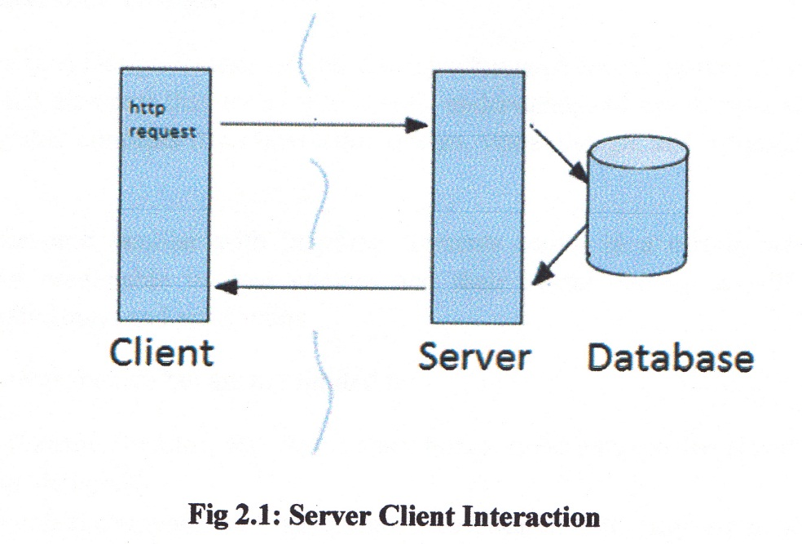

**2.4 How Java Server Pages works**

A page using Java Server Pages is executed during the query, by a J SP engine (generally running with a Web server or an application server). The J SP model is derived from the one used for Java servlets (J SP are indeed a way to write servlets). It is a Java class derived from HttpServlet class, making use of using doGet() and doPost() to return an HTTP response [6].

When a user calls a JSP page, the Web server calls the J SP engine which creates a Java source code from the JSP script and compile the class to provide a compiled ﬁle (with the .class extension) [6].

The JSP engine checks if the date of the. JSP ﬁle corresponds to the .class ﬁle. The JSP engine will convert and compile the class, only if the J SP script has been updated. Thus, the fact that the compilation only takes place when the J SP script is updated makes JSP, one of the fastest

technologies to create dynamic pages.

**2.5 JSP Runtime Environment**

Running JSP ﬁles needs a JSP supported web server. The commonly user server is 13055 and Tomcat. Tomcat is a Servlet and F8? container developed by the Apache Software Foundation (ASF). Tomcat compiles the Java servlet and provides a Java-based web server environment for Java code to run.

**2.6 User Interface Design**

User Interface (UI) Design focuses on anticipating what users might need to do and ensuring that the interface has elements that are easy to access, understand, and use to facilitate those actions. UI brings together concepts from interaction design, visual design, and information architecture [7].

Users have become familiar with interface elements acting in a certain way, so try to be consistent and predictable in your choices and their layout. Doing so will help with task completion, efﬁciency, and satisfaction.

Interface elements include but are not limited to:

* Input Controls: buttons, text ﬁelds, checkboxes, radio buttons, dropdown lists, list boxes, toggles, date ﬁeld
* Navigational Components: breadcrumb, slider, search ﬁeld, pagination, slider, tags, icons
* Informational Components: tooltips, icons, progress bar, notiﬁcations, message boxes, modal windows
* Containers: accordion

There are times when multiple elements might be appropriate for displaying content. When this happens, it’s important to consider the trade-offs. For example, sometimes elements that can help save you space, put more of a burden on the user mentally by forcing them to guess what is within the dropdown or what the element might be.

Everything stems from knowing your users, including understanding their goals, skills, preferences, and tendencies. Once you know about your user, make sure to consider the following when designing your interface [7]:

* Keep the interface simple. The best interfaces are almost invisible to the user. They avoid unnecessary elements and are clear in the language they use on labels and in messaging.
* Create consistency and use common UI elements. By using common elements in your UI, users feel more comfortable and are able to get things done more quickly. It is also important to create patterns in language, layout and design throughout the site to help facilitate efﬁciency. Once a user learns how to do something, they should be able to transfer that skill to other parts of the site.
* Be purposeﬁil in page layout. Consider the spatial relationships between items on the page and structure the page based on importance. Careful placement of items can help draw attention to the most important pieces of information and can aid scanning and readability.
* Strategically use color and texture. You can direct attention toward or redirect attention away from items using color, light, contrast, and texture to your advantage.
* Use typography to create hierarchy and clarity. Carefully consider how you use typeface. Different sizes, fonts, and arrangement of the text to help increase scan ability, legibility and readability.
* Make sure that the system communicates what’s happening. Always inform your users of location, actions, changes in state, or errors. The use of various UI elements to communicate status and, if necessary, next steps can reduce frustration for your user.
* Think about the defaults. By carefully thinking about and anticipating the goals people bring to your site; you can create defaults that reduce the burden on the user. This becomes particularly important when it comes to form design where you might have an opportunity to have some ﬁelds pre-chosen or ﬁlled out.

**2.6.1 JAVA SCRIPT**

JAVA SCRIPT is a dynamic computer programming language. It is most commonly used as part of web browsers, whose implementations allow client-side scripts to interact with the user, control the browser, communicate asynchronously, and alter the document content that is displayed. It is also used in server-side network programming with frameworks such as Node.js, game development and the creation of desktop and mobile applications [8].

JavaScript is classiﬁed as a prototype-based scripting language with dynamic typing and ﬁrst- class functions. This mix of features makes it a multi-paradigm language, supporting object- oriented, imperative, and functional programming styles [8].

Despite some naming, syntactic, and standard library similarities, JavaScript and Java are otherwise unrelated and have very different semantics. The syntax of JavaScript is actually derived from C, while the semantics and design are inﬂuenced by Scheme programming languages.

JavaScript is also used in environments that aren't web-based, such as PDF documents, site- speciﬁc browsers, and desktop widgets. Newer and faster JavaScript virtual machines (V Ms) and platforms built upon them have also increased the popularity of JavaScript for server-side web

applications. On the client side, JavaScript has been traditionally implemented as an interpreted language, but more recent browsers perform just-in-time compilation [8].

**2.6.2 XML**

Extensible Markup Language (XML) is a markup language that deﬁnes a set of rules for encoding documents in a format which is both human-readable and machine-readable. It is deﬁned by the W3C's XML 1.0 Speciﬁcation and by several other related speciﬁcations, all of which are free open standards [12].

The design goals of XML emphasize simplicity, generality and usability across the Internet. It is a textual data format with strong support via Unicode for different human languages. Although the design of XML focuses on documents, it is widely used for the representation of arbitrary data structures such as those used in web services.

Several schema systems exist to aid in the deﬁnition of XML-based languages, while many application programming interfaces (APIs) have been developed to aid the processing of XML data.

**PostgreSQL: PostgreSQL**, often simply **Postgres**, is an [object-relational database management system](https://en.wikipedia.org/wiki/Object-relational_database_management_system) (ORDBMS) with an emphasis on extensibility and standards-compliance. As a database server, its primary function is to store data securely, supporting best practices, and to allow for retrieval at the request of other software applications. It can handle workloads ranging from small single-machine applications to large [Internet-facing applications](https://en.wikipedia.org/wiki/Web_service) with many [concurrent users](https://en.wikipedia.org/wiki/Concurrent_user).

PostgreSQL implements the majority of the [SQL:2011](https://en.wikipedia.org/wiki/SQL:2011) standard, is [ACID](https://en.wikipedia.org/wiki/Atomicity,_consistency,_isolation,_durability)-compliant and [transactional](https://en.wikipedia.org/wiki/Transaction_processing) (including most [DDL statements](https://en.wikipedia.org/wiki/Data_Definition_Language)) avoiding locking issues using [multiversion concurrency control](https://en.wikipedia.org/wiki/Multiversion_concurrency_control) (MVCC), provides immunity to [dirty reads](https://en.wikipedia.org/wiki/Isolation_(database_systems)#Dirty_reads) and full[serializability](https://en.wikipedia.org/wiki/Serializability); handles complex [SQL](https://en.wikipedia.org/wiki/SQL) queries using many indexing methods that are not available in other databases; has updateable[views](https://en.wikipedia.org/wiki/View_(SQL)) and [materialized views](https://en.wikipedia.org/wiki/Materialized_view), [triggers](https://en.wikipedia.org/wiki/Database_trigger), [foreign keys](https://en.wikipedia.org/wiki/Foreign_key); supports functions and stored procedures, and other expandability, and has a large number of extensions written by third parties. In addition to the possibility of working with the major proprietary and open source databases, PostgreSQL supports migration from them, by its extensive standard SQL support and available migration tools. Proprietary extensions in databases such as [Oracle](https://en.wikipedia.org/wiki/Oracle_Database) can be emulated by built-in and third-party open source compatibility extensions. Recent versions also provide replication of the database itself for availability and [scalability](https://en.wikipedia.org/wiki/Scalability).

**Android :** Android is a [mobile operating system](https://en.wikipedia.org/wiki/Mobile_operating_system) (OS) currently developed by [Google](https://en.wikipedia.org/wiki/Google), based on the [Linux kernel](https://en.wikipedia.org/wiki/Linux_kernel) and designed primarily for [touchscreen](https://en.wikipedia.org/wiki/Touchscreen) mobile devices such as [smartphones](https://en.wikipedia.org/wiki/Smartphone) and [tablets](https://en.wikipedia.org/wiki/Tablet_computer). Android's [user interface](https://en.wikipedia.org/wiki/User_interface) is mainly based on [direct manipulation](https://en.wikipedia.org/wiki/Direct_manipulation_interface), using touch gestures that loosely correspond to real-world actions, such as swiping, tapping and pinching, to manipulate on-screen objects, along with a [virtual keyboard](https://en.wikipedia.org/wiki/Virtual_keyboard) for text input. In addition to touchscreen devices, Google has further developed [Android TV](https://en.wikipedia.org/wiki/Android_TV) for televisions, [Android Auto](https://en.wikipedia.org/wiki/Android_Auto) for cars, and [Android Wear](https://en.wikipedia.org/wiki/Android_Wear) for wrist watches, each with a specialized user interface. Variants of Android are also used on [notebooks](https://en.wikipedia.org/wiki/Laptop), [game consoles](https://en.wikipedia.org/wiki/Video_game_console), [digital cameras](https://en.wikipedia.org/wiki/Digital_camera), and other electronics. As of 2015, Android has the largest [installed base](https://en.wikipedia.org/wiki/Installed_base) of all operating systems.

Initially developed by Android, Inc., which Google bought in 2005, Android was unveiled in 2007, along with the founding of the [Open Handset Alliance](https://en.wikipedia.org/wiki/Open_Handset_Alliance) – a consortium of [hardware](https://en.wikipedia.org/wiki/Computer_hardware), software, and telecommunication companies devoted to advancing [open standards](https://en.wikipedia.org/wiki/Open_standard) for mobile devices. As of July 2013, the [Google Play](https://en.wikipedia.org/wiki/Google_Play) store has had over one million Android applications ("apps") published, and over 50 billion applications downloaded. An April–May 2013 survey of mobile application developers found that 71% of developers create applications for Android,[[15]](https://en.wikipedia.org/wiki/Android_(operating_system)#cite_note-visionmobile1-17) and a 2015 survey found that 40% of full-time professional developers see Android as their priority target platform, which is comparable to [Apple](https://en.wikipedia.org/wiki/Apple_Inc.)'s [iOS](https://en.wikipedia.org/wiki/IOS) on 37% with both platforms far above others. At [Google I/O](https://en.wikipedia.org/wiki/Google_I/O) 2014, the company revealed that there were over one billion active monthly Android users, up from 538 million in June 2013.

**Chapter 3**

**Requirement Analysis**

In this chapter , we are going to analysis different types of requirement for our project. We can divide our require into three parts: functional requirement , Hardware requirement and software requirement. We will discuss about these topics in this chapter.

**3.1. Functional Requirement**

In our project, we have three types of functional requirement: admin, student, and mobile apps

**3.1.1. Admin**

* Admin login
* Manage the result of the student
* Insert and update result

**3.1.2 Student**

* Student will search the result in website

**3.1.3 Mobile apps:**

* This is the another part of student where they can get the result through their mobile apps

**3.3 Non-Functional Requirements**

* Secure access by confidential data by username and password. This application is secure for every kind of its users because nobody can access the admin panel without his or her password. As a result the student result will remain secure by authority.
* The database used here is robust , reliable and fast .Therefore, users will have to wait for the output very short time
* This application can access from any type of platform

**3.2 Hardware Requirements**

* Processor : 2.6 GHz Intel core i3
* Memory : 6 GB
* Diskspace : 2 GB of free disk space

**3.3 Software Requirements**

Software plays an important role in any project development .One should know which software to use to develop the project. Our application is developed using

* Operating system : Windows 10
* Database : PostgreSQL
* Tools : Netbeans , Android Studio

**Chapter 4**

**Software Design**

To solve actual problems a software engineer or a team of engineers must incorporate a development strategy that encompasses the process , methods and tools and some generic phases. In this section , a number of mostly used process models and the Data.In this chapter we have discussed about software process model and design pattern of our software.

**4.1 Software Processes model**

First of all, We can start from a very interesting question “Can software engineering principles, concept and methods be applied to website development?” The answer is many of them can but their application may require a somewhat different span.

Now we can go tor the software process model. A software process model is an abstract representation of a process that is a structured set of activities required to develop a software process models are:

* Specification what the system should do and its development constraints?
* Design and implementation –production of the software system.
* Validation –Checking that the software is what the customer wants.
* Evaluation-changing the software in response to changing demands

There are different types of software processing model such as waterfall model, prototype model, spiral model etc. We have discussed shortly about these software process model.

**4.1.1 Waterfall Model**

The waterfall model is a systematic and sequential approach to software development that begins with customer specification of requirements and progress through planning , modeling, construction and deployment, culminating in ongoing support of the completed software. The phases of waterfall model are :

* Requirement analysis
* System and software design
* Implementation and unit testing
* Integration and system testing

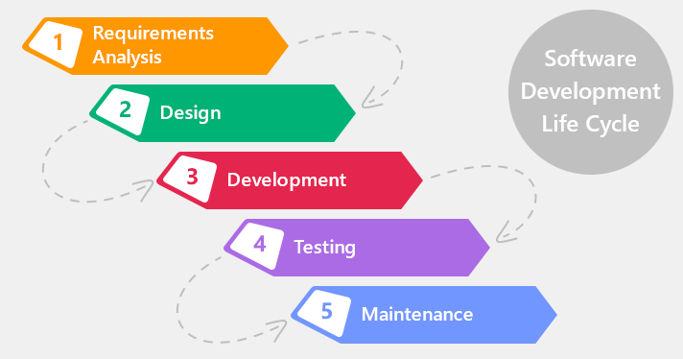

Figure : waterfall model

In Fig 4.1, We can see the phase of waterfall model. Real projects rarely follow it as it is difficult to establish all requirements explicitly, no room for uncertainty. When the requirements of a problem are reasonably well understood and project duration is very short then waterfall model is suitable. The main drawback of the waterfall model is the difficulty of accommodating change after the process is underway. One phase has to be completed before moving onto the next phase.

**4.1.2 Prototype Model**

Often a customer defines a set of general objectives for software , but does not identify detailed input, processing or output requirements. In other cases, the developer may be unsure of the efficiency of an algorithm, the adaptability of an operating system, or the form that human-machine interaction should take. In these, and other situation, prototype paradigm may offer better result.

The prototyping paradigm begins with requirements gathering. Developer and customer meet and define the overall objectives for the software , identify whatever requirements are known, and outline areas where further definition is mandatory. A “quick desing” then occurs. The quick design focuses on a representation of those aspects of the software that will be visible to the construction of a prototype. The prototype is evaluated by the customer/user and used to renew requirements for the software to be developed. Iteration occurs as the prototype is tuned to satisfy the needs of the customer, while at the same time enabling the developer to better understand what needs to be done.

In Fig-2, We can see the process of prototype model.

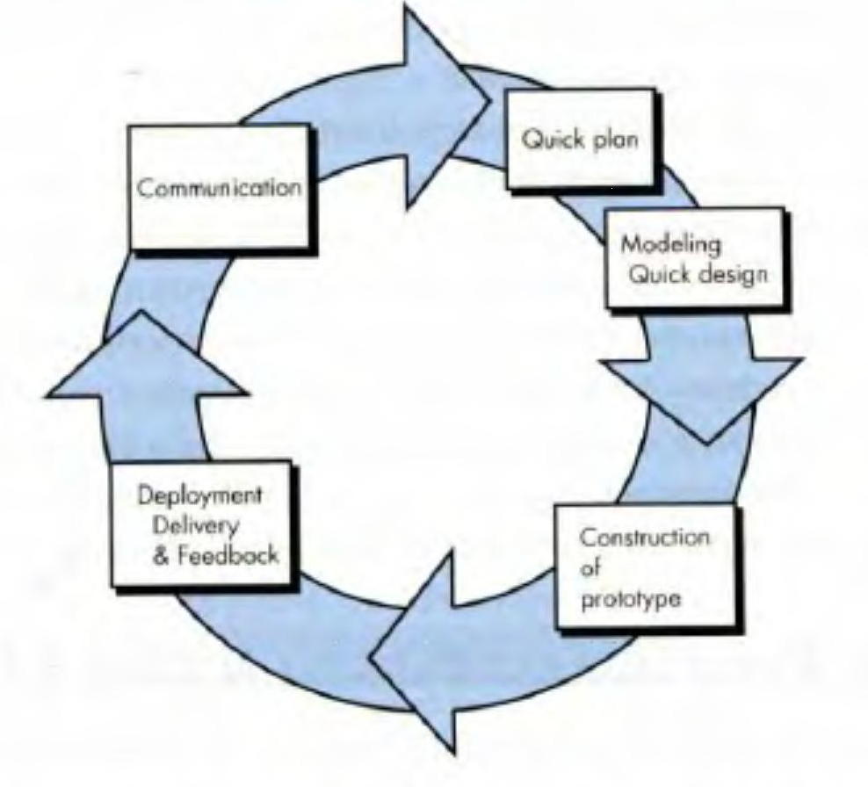

Figure: 4.2 Prototype Model

**4.1.3 Spiral Model**

The Spiral Development (or Lifecycle) Model is a system development method used in information technology. Encompasses the previous models as special cases, and can make use of a combination of models. Risk analysis asks, “What are the areas of uncertainty, and what is the probability that they will slow the progress of development?” It combines the feature of the prototyping model and the waterfall model. The phases and the waterfall model . The phases of spiral model are

* Planning
* Risk Analysis
* Engineering
* Release
* Evaluation and Communication with the customer

These phases are iteratively followed one after other in order to eliminate all the problems which were faced in “The waterfall Model”. Iterating the phases helps in understanding the problems associated with a phase and dealing with those problems when the same phase is repeated next time, planning and developing strategies to be followed while iterating through the phases.

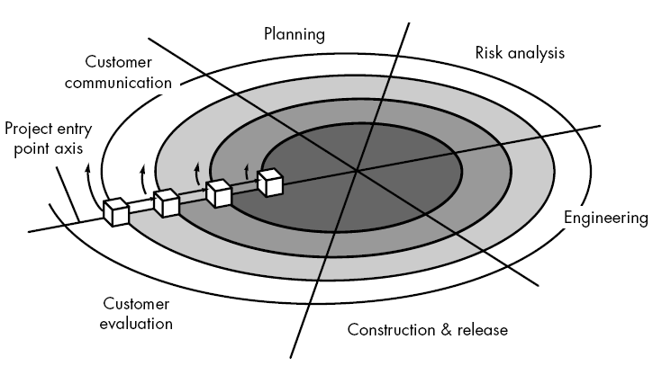

Figure. 4.2: Spiral Model

In Fig. 4.3 we can see a process of spiral model . The strengths of spiral model are given below

* Provides early indication of insurmountable risks, without much cost.
* Users see the system early because of rapid prototyping tools
* Critical high-risk functions are developed first
* Users can be closely tied to all lifecycle steps
* Early and frequent feedback from users.

There is some weakness in the spiral model. We give some major weakness of spiral model

* Risk assessment expertise is required.
* Developer must be reassigned during non-development phase activities .
* Time spent for evaluating risks too large for small or low-risk projects

**4.1.4: Choosing the Appropriate Process Model**

We have chosen the spiral model to implement our project . The spiral model is a realistic approach to the development of large scale systems and software . Because software evolves as the progresses, the developer and customer better understand and react to risks at is evolutionary level. It maintains the systematic step wise approach suggested by the classis life cycle but incorporates it into an iterative framework that more realistically reflects the real world. The spiral model demands a direct consideration of technical risks at all stages of the project, and if properly applied, should reduce risks before they become problematic. It also combines the feature of the waterfall and prototyping model. Under this consideration we found that spiral model fulfills most of the requirements of our system. That is why we have chosen this model.

**4.3 Manual**

In this section we will give the overview of all the pages which we have developed for our software “Online Result Processing System With mobile app”.

**4.3.1 Home Page**

Home page is the front page in our Online result processing system. This page contains the login page links where admin of the website can login and result where users or students can search their result according to their roll, batch , shift or other necessary information.

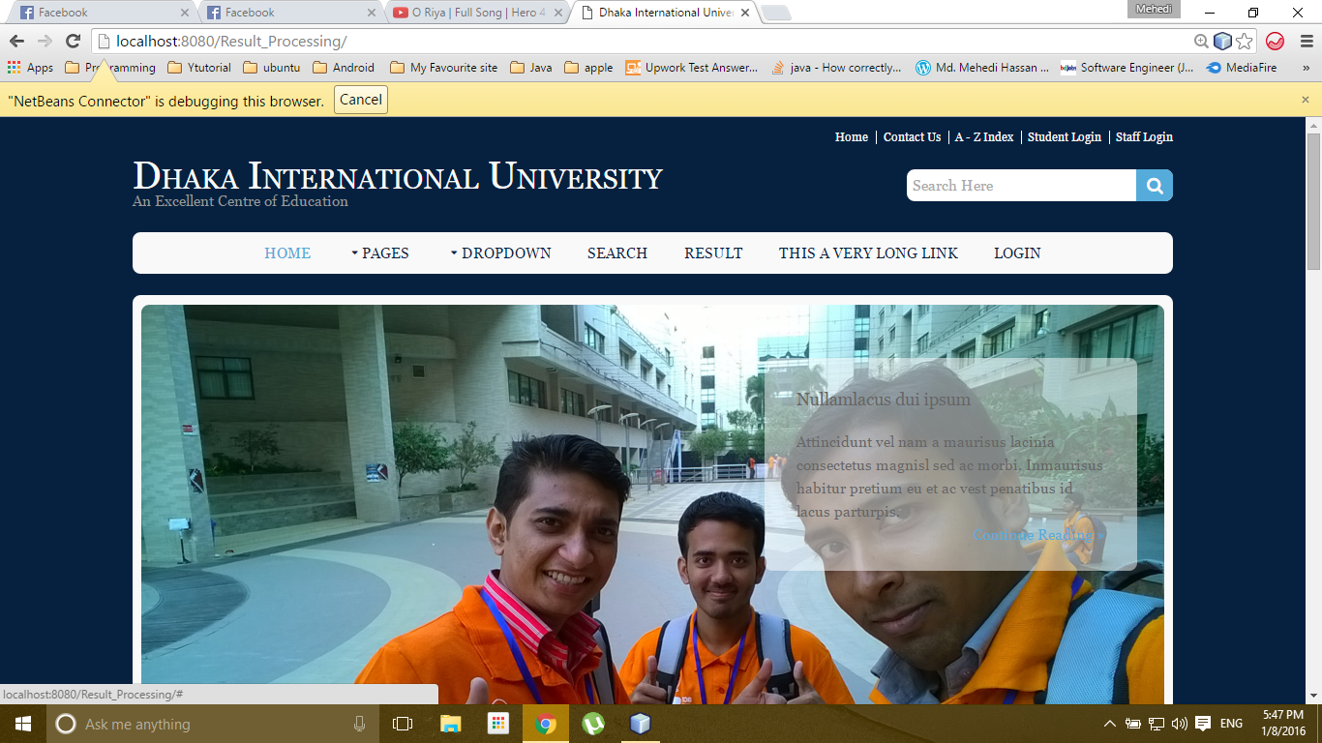

Fig : HomePage

**4.3.2 Admin Login Page**

To insert or update the result the admin has to login to the admin panel.Admin login page is the web page where admin log in the website for any modification of the university result.

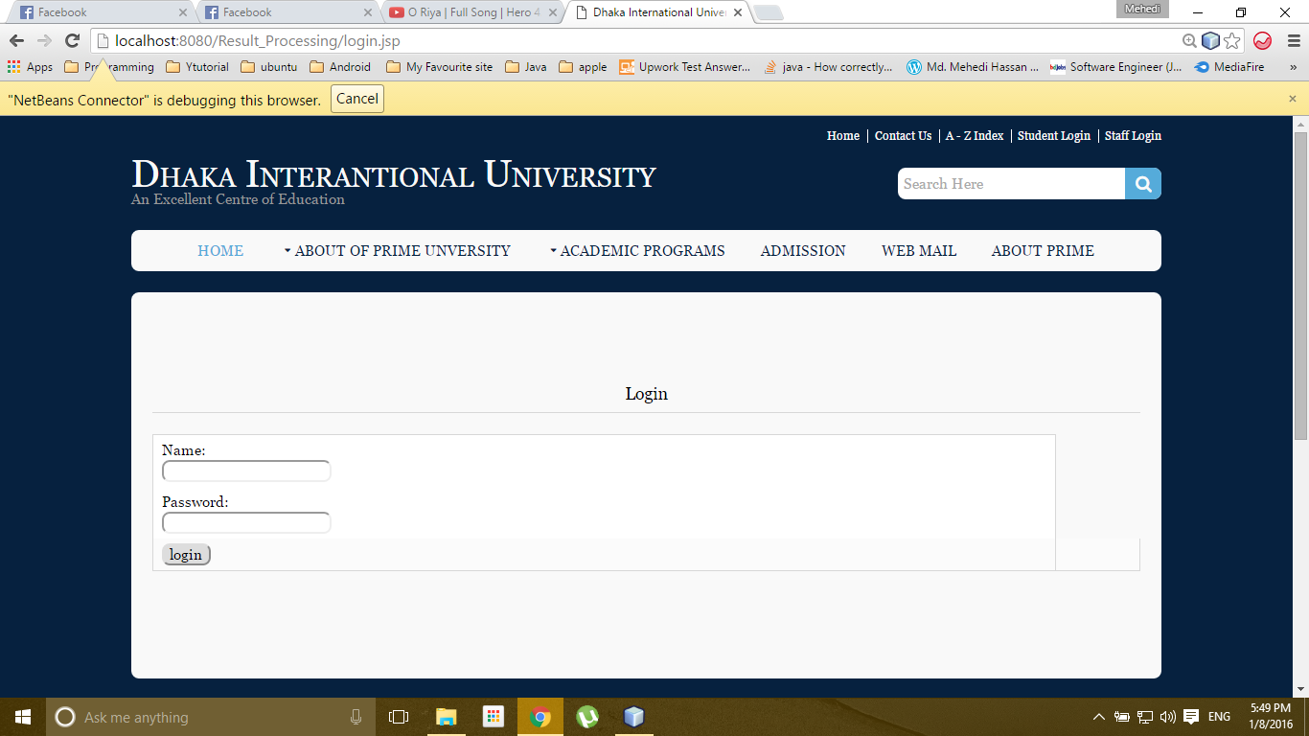

Figure :Admin Login Page

**4.3.3 Insert Page**

After successfully login the admin or authority can insert the student result giving the proper information of individual student. After giving the information in the form we have to press insert button to insert the result successfully .if the result is inserted successfully there will be message about data insertion.

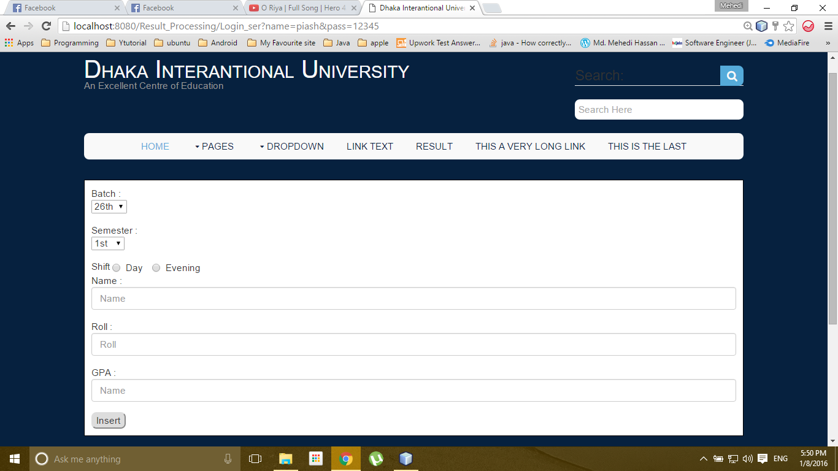

Figure: Insert Page

**4.3.4 Result Page**

In this page the student can search their result giving the particular information like roll number, batch, shift , semester. After giving the information they have to press the search button to see the result.

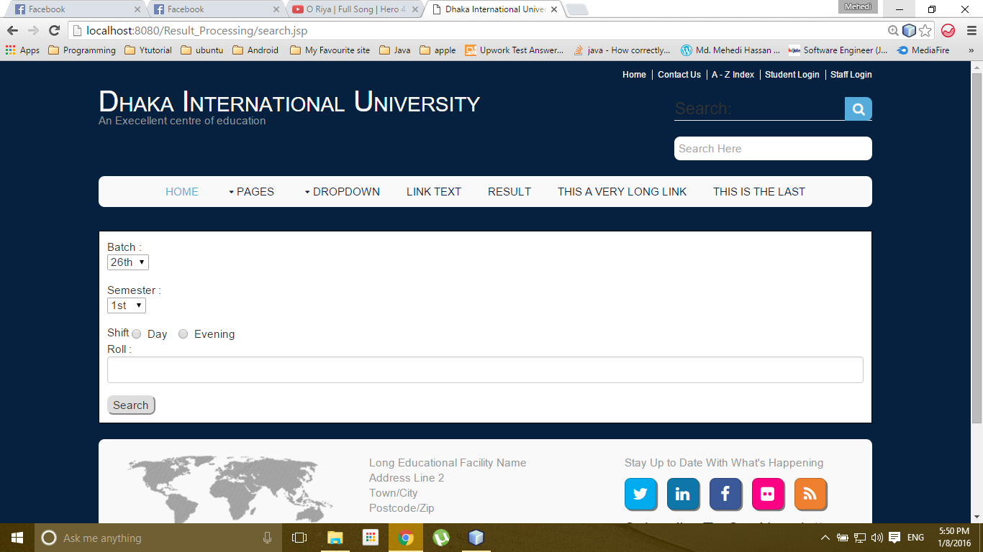

Figure : Result page

**4.3.5 Show Result Page**

When the student give the appropriate information in result page for getting their result if the information match to our database it will return the student result and show in the show result page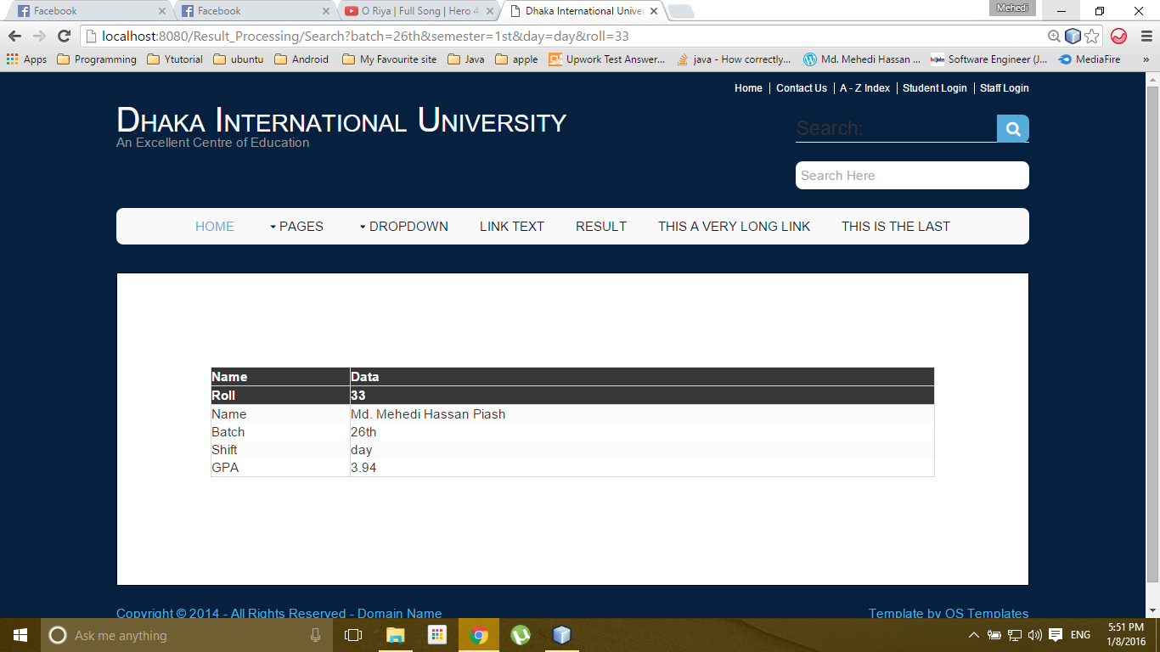

**4.4 Mobile App for Android**

**4.4.1 Splash Screen Activity**

This the splash screen of the DIU logo which shows while the apps starts.



Figure: Splash Screen of Mobile Apps

**4.4.2 Home Activity**

This is an Activity where all of the keyword is shown as button with their particular listen event like Result, Faculty, About us etc. After clicking the button we can go the next activity of the our app

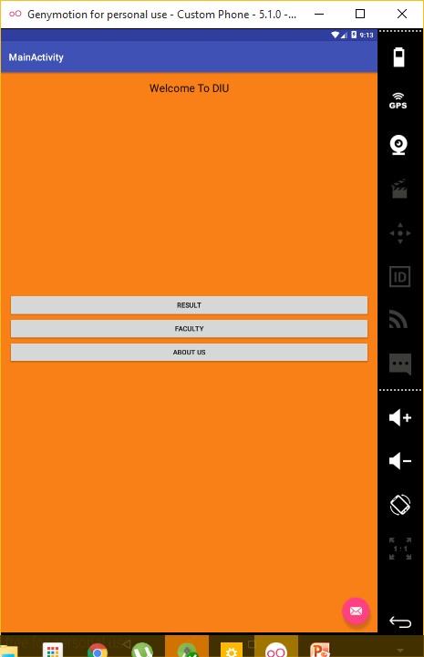

Figure : Home Activity

**4.4.3 Result Activity**

In this activity we can search our result giving the proper information in the TextField which is known as EditText in android. Then we have to click the search button the json will be sent to our API to fetch the result.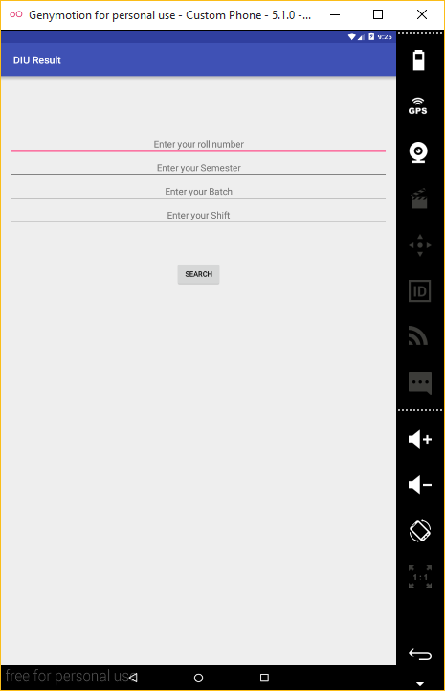

Figure :Result Activity

**Chapter 5**

**Overall Discussion**

**6.1 Conclusion**

This project has been developed successfully incorporate all the requirements. Appropriate care has taken during database design and maintain database integrity and to avoid redundancy of data. Our Result Processing System is developed in such a way that any furthers modification needed can be easily done. We have also tried to make our application user friendly, therefore users feel free to use our application.

This project has tried to put in all the information that is need in this project and this project will help the student to get their result in their expected time without further delay.

**6.2 Limitation**

This project is designed provide service for student in mobile apps. But Teacher can access their admin panel through the mobile apps.

**6.3 Future works**

We have some goals that we will fulfill in future.

* Add admin panel for teacher in our mobile apps
* Add a registration section for student through they can comment in website
* Show the result subject wise in every semester

We hope that in future we can add many useful feature to our site to make it more promising for the users.

**Bibliography**

1. <http://www.tutorialspoint.com/>
2. <https://en.wikipedia.org/wiki/PHP>
3. <http://www.oracle.com/technetwork/java/javaee/downloads/index.html>
4. <http://www.w3schools.com/xml/>
5. <https://en.wikipedia.org/wiki/JavaScript>
6. <http://www.tutorialspoint.com/postgresql/>
7. <http://developer.android.com/index.html>
8. <http://www.w3schools.com/html/>
9. <http://www.free-css.com/template-categories/education>
10. <http://www.oracle.com/technetwork/java/javase/downloads/index.html>